**Objective Questions**:

1. What is the total no. of tables present in the data?

There is only single table in the data.

1. What is the total no. of attributes present in the data?

There is total 31 attributes present in Astrosage Data.

1. The data consists of some inconsistent and missing values so ensure that the data used for further analysis is cleaned?

The steps followed to clean data: -

* First checking duplicates by using Conditional Formatting and then removing them using “Remove Duplicates” functionality in Data Ribbon.
* Deleting columns which re not suitable for analysis like “isWhiteListUser”, “_v” etc. on the basis what kinds of values column contains and how many blanks it has.
* Now for filling missing values, used IF(), ISBLANK(), AVERAGEIF(), COUNTIF() functions.
* The values used to fill blanks are: -
  + Chat Status – Unknown
  + Chat Seconds – IF(ISBLANK(), AVERAGEIF(), same value in cell) like that formula
  + Call Channel – Undefined
  + VRType – Undefined
  + Call Status, Astrologer Call Status and User Call Status – No_Status
  + Astrologer_On_Call_Duration, Astrologer_On_Call_Duration, Amount, Astrologer Earnings - IF(ISBLANK(), AVERAGEIF(), same value in cell) kind of formula
  + Net Amount – Amount – Astrologer Earnings

1. What is the change in daily call volume day by day and also find the average of daily call volume?

To approach this,

* First, we will find unique dates at which calls are created using “UNIQUE” function from the Created_Date column.
* Then using COUNTIFS() function we will find count of calls on each day and Consultation_Type as “Call”.
* The to calculate change we will subtract Total Calls on next day from the previous one. The average of rate of change comes out to be -7.3 or -7 calls, i.e. everyday 7 calls less they are receiving.
* Also Average of Daily Call Volume is found out using AVERAGE() function and it comes out to be 249.7 or 250 calls per day.

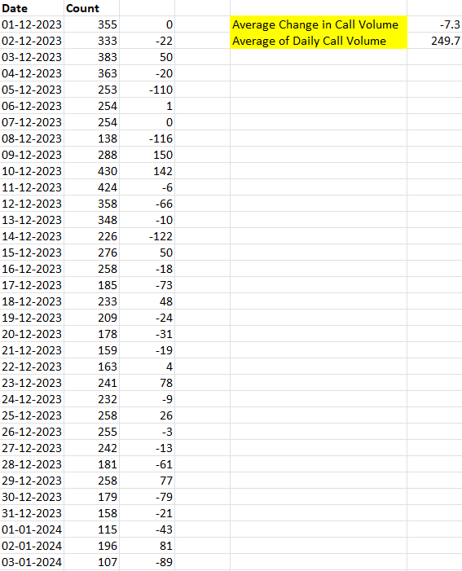

1. Which months experienced the highest and lowest call volumes?

Since there are two Months only in the Dataset, December 2023 and January 2024. December has highest call rates. As we can verify from pivot table.

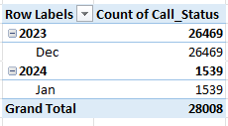

1. What is the total operational cost for that month?

In December Total Amount gained by company is 6,32,816 in which 2,90,768 goes to Astrologers, so Profit to company is 3,42,048.

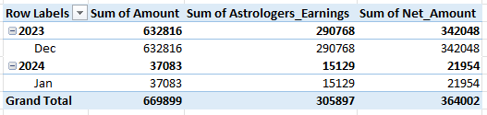

1. What is the average number of calls handled per agent per day?

The approach for this

* First we will calculate How many total “Calls” are there, and use the COUNTIF() function for this. The number comes out to be 8490 calls.
* To calculate number of agents, we use combination of COUNTA(UNIQUE(g_ids)) and we get 131 unique agents. Siimilarly we will calculate distinct number of days using Created_Date column and number comes out to be 34.
* So Average number of Calls per agent per day is (8490/131)/34, and it is around 1.9 or 2 calls.

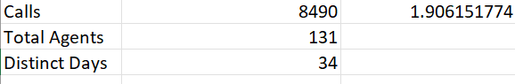

1. How many repeat callers are there, and what percentage of total calls do they represent?

* There are 1,277 repeat callers are present, this can be found out by creating a pivot, taking U_id in rows and count of Call_Status in Values and Filtering them out on the basis of Consultation type by selecting “Call” as its type. And also placing the Value Filter of Greater than 1 for the rows. Now subtracting 1 from each count value, we get the calls made by repeated callers. Summing it up we get 4861 total calls
* To get the total calls, we can remove the value filter and check the grand total, it is 8490 calls.
* So, the % comes out to be (4861/8490) * 100 is 57.25%.
* Pivot table is drawn in Answer Pivots sheet in K1 cell.

1. What are the total sales generated by the call centre for each product category?

Most sales are generated by “Chats” which are 3,80,287 and also has the main source of profit of 2,17,822. Next is the Calls with the total sales of 2,89,490 and profit of 1,46,133. But the Complementary Consultation has caused the company a loss of 13 which is not that significant.

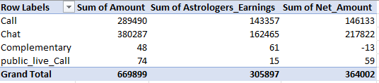

1. How many calls were made for each user ID and guru ID?

There are 8,490 total calls were made. On an average for each Guru 75.8 calls are made among 112 Gurus. As for Users, the average calls made by them are 2.3 calls among 3,630 Users.

The Pivot tables are present in “Answer Pivots” sheet, with names as “Total Calls per user” and “Total Calls per Guru”.

1. What is the correlation between call duration and customer satisfaction?

The Correlation is positive but the “R-squared” value is very close to 0, it is 0.0004 and the trendline has negative slop.

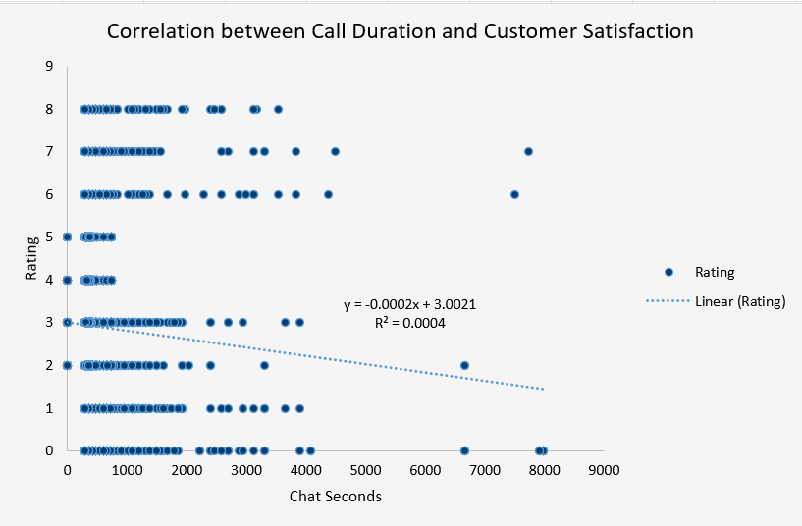

1. Which guru have the highest and lowest customer satisfaction scores?

Pujaa Rai and Mystical, who is Astro and Tarot Designation respectively has highest Average Satisfaction rating with 7.5/10. Lowest is 0.0 for Rittika who is Tarot.





1. What is the average customer satisfaction score by month?

2023 December – 2.9

2024 January – 2.7

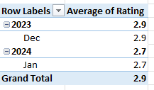

1. How many categorical columns are there in the data?

There are 16 Categorical columns and these are: -

* Chat Status
* Consultation Type
* Website
* Refund Status
* isWhiteListUser
* queue
* Free Call
* Free Chat
* _v
* Call Channel
* CallvrType
* Call Status
* Astrologer Call Status
* Region
* User Call Status
* Rating

**Subjective Question:**

1. Should the investment be used to hire more agents, improve training programs, or upgrade call centre technology?

To talk about investment Allocation, here upgrading Call centre Technology is very much crucial than other two i.e. Hiring and training. Reasons are: -

* Technology Upgrades: -

1. Peak periods (e.g., December) strain resources, increasing costs. Advanced scheduling tools and AI optimize resource utilization and manage high call volumes efficiently.
2. Data collection technology is crucial to gather meaningful insights without losing data. As we can see that percentage of Unknown Chats and No Status Calls are way more than the other categories, so data collection technology needs to be improved.

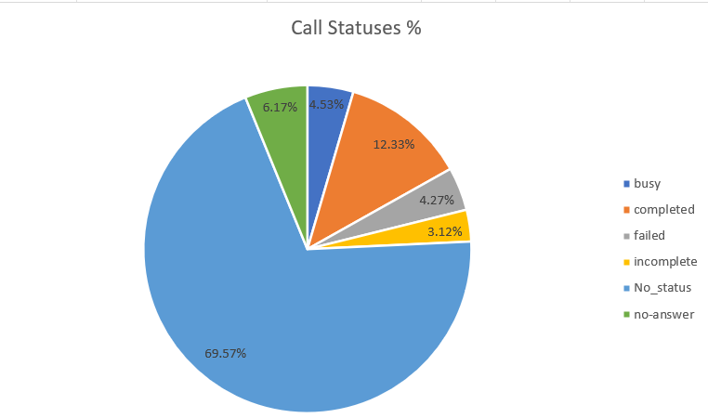

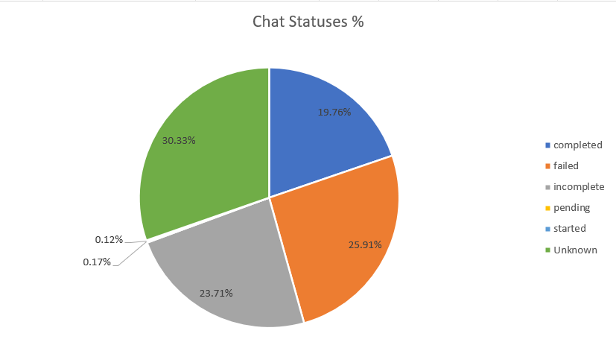

* Training Programs: -

1. Customer satisfaction depends on consistent service quality. Training low-performing agents, like Tarot Rittika, will improve retention and satisfaction.
2. Experienced agents can mentor others, enhancing overall performance.
3. Also, as we can see that most agents prefer chats over calls, so we also need some training program to help agents to improve their Conversational proficiency so that they can increase their call durations.

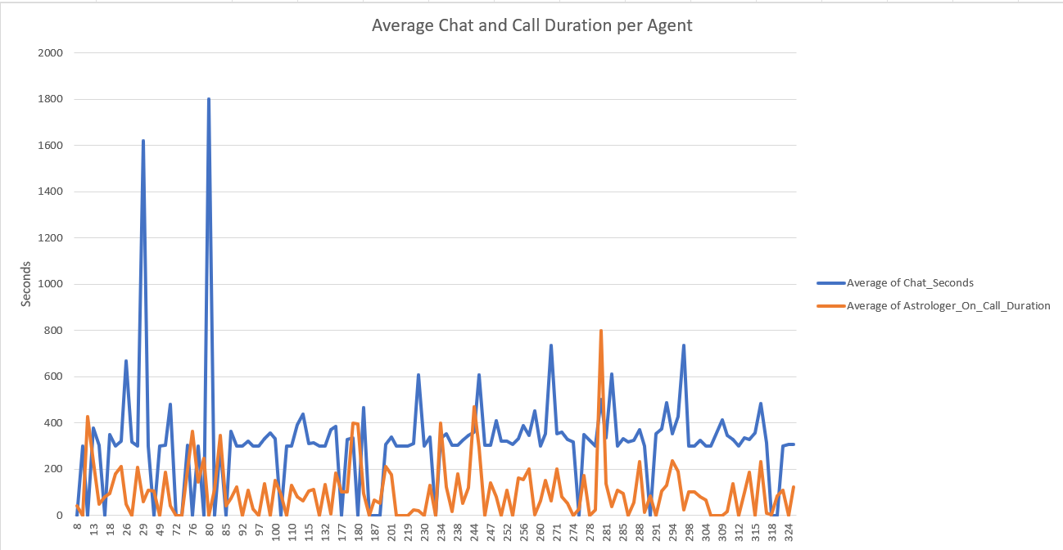

* Hiring: -

1. While hiring reduces agent workload and increases call capacity, training existing agents is more cost-effective and boosts satisfaction scores, benefiting long-term growth.
2. This is because as we can see from the line chart below that most Average Ratings are falling under 2-5 range and good part is slope of trend line is positive indicating positive rating score for most Gurus.
3. So, training these agents will be more effective than hiring new ones. Company an also fire those who have Average rating below 1 and get new hired Professional agents.

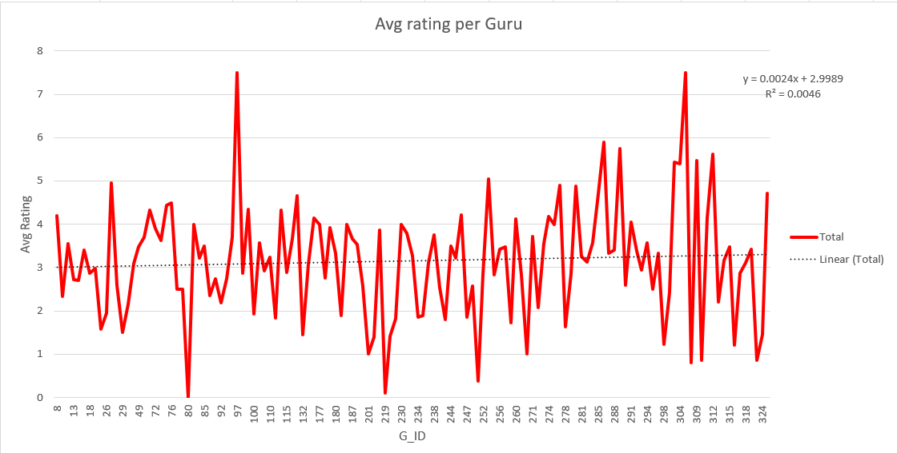

1. What are the potential risks of each investment option (hiring, training, technology upgrades), and how can they be mitigated?

All the investments which are done in Training, Hiring and Technology comes with their risks and those risks needs to be mitigated for company to function properly

* + Hiring Risks
* **Underutilization**: Poor forecasting may leave agents idle during low demand.
* **Increased Costs**: Salaries for new hires raise fixed costs.
* **Quality Issues**: Insufficient vetting can lower customer satisfaction.
* **Mitigation**: Use historical data to forecast demand, hire part-time agents for peaks, and implement robust hiring criteria.

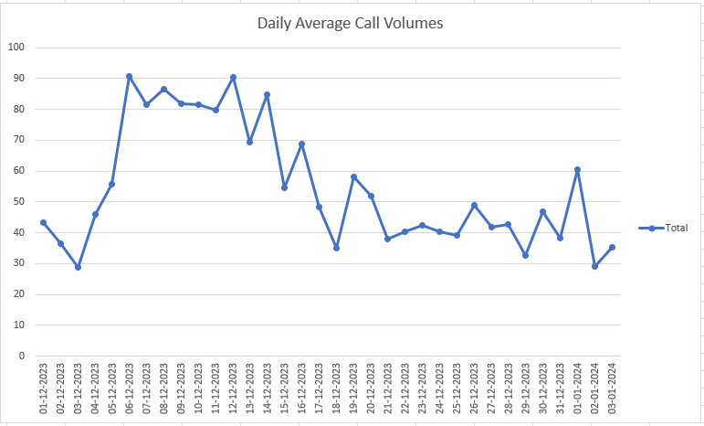

* + Training Risks
* **Costly and Uncertain Impact**: Not all agents improve post-training.
* **Operational Strain**: Training pulls agents from duty, increasing pressure on others.
* **Resistance**: Some agents may resist new practices.
* **Mitigation**: Focus on low-performing agents, schedule training during off-peak periods, and use high-performing astrologers as mentors to ensure effectiveness and foster relationships.

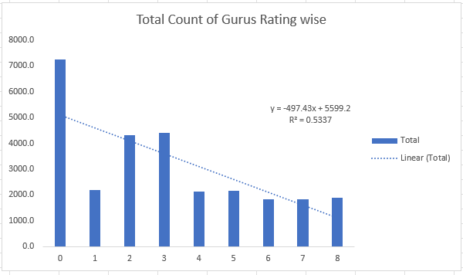

We can clearly observe that slope of trendline is highly negative, due to large number of agents having 0 average rating. Company needs to improve that by training.

* + Technology Upgrades Risks
* **Disruption**: New tools can disrupt workflows during adoption.
* **High Costs**: Initial deployment may strain budgets.
* **Agent Adaptation**: Some agents may struggle with new technology.
* **Mitigation**: Start with pilot programs, ensure scalability to control costs, and provide training for agents to adapt comfortably.

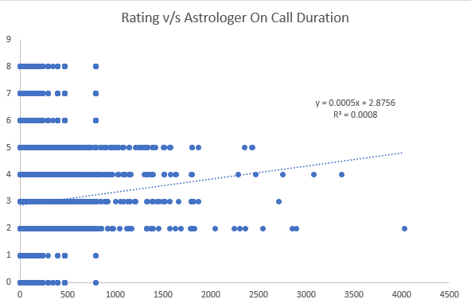

As we can see from the Correlation Chart between Rating and Astrologer-On Call Duration that Astrologers having Ratings between 2-5 have many calls. So, by training them to use new tech helps the trendline to become more steeper which means high on call durations with high rating.

1. How does AstroSage call centre performance compare to that of AstroGuru in terms of average call volume, customer satisfaction, and agent performance? Will you use any aggregation function or a visualization here to solve the problem?

Since no Data is provided for AstroGuru, so comparisons can be drawn.

1. How can the call centre improve its handling of peak call periods to ensure high customer satisfaction?



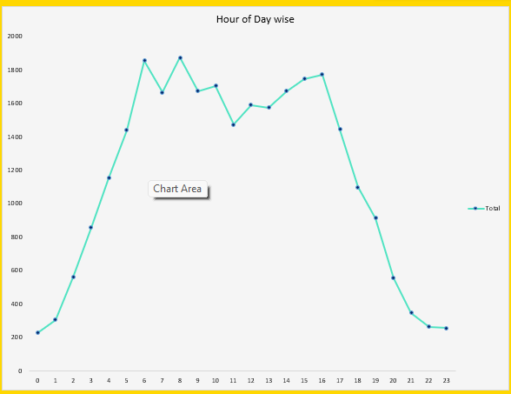

December sees higher call volumes than January, especially during peak hours (5 AM to 6 PM, with over 1,000 calls). Efficient forecasting and proactive resource allocation during these times can prevent delays and enhance service. Assigning the highest-rated agents to peak hours will further boost customer satisfaction.

1. Based on historical data, what strategic initiatives should be prioritized to improve overall efficiency and customer satisfaction?



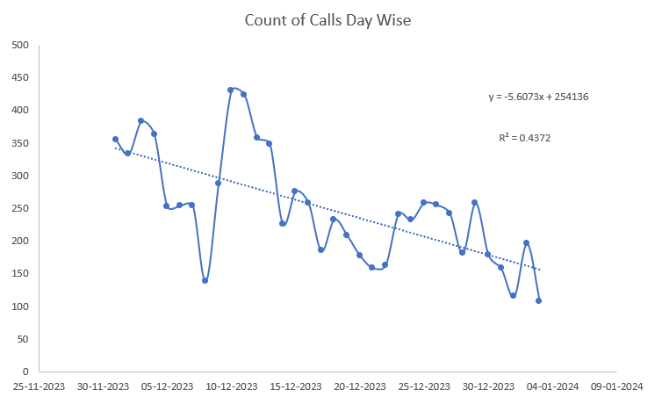

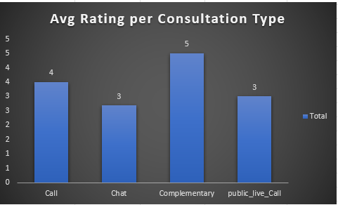

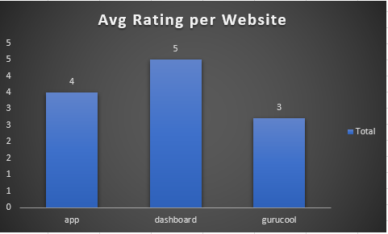

The correlation between ratings and call duration is near zero **(R^2 = 0.0004),** with ratings dropping as call length increases, except for calls over 2000 seconds. Also, in count of calls trendline has highly negative slope, with 0.4 R^2 value, indicating calls are sharply falling day by day on an average. To improve this correlation and make the trend positive, the company can:

* Foster personalized interactions between agents and customers.
* Provide regular training and monitor agents' progress.
* Create a supportive, hassle-free work environment for agents.
* Integrate technology to reduce agent workload.
* Use effective forecasting to ease pressure during peak hours.
* Also, Average Rating is less in Chats than Calls which can be improved using AI Chatbots integration.
* Average Rating in Gurucool website is less than others, so it also needs technological upgrades to facilitate good user experience and Company should also work on their dashboard so more users will come through that.

1. What can be the key factors contributing to high customer satisfaction scores, and how can these be leveraged to improve overall performance? What is the basis for the suggestions? And mention how did you decide if the satisfaction score affect the ratings?
   * Agent Performance – High-rated agents perform well, so focus on low-ratings agents by these Gurus can improve overall performance,
   * Customers are more satisfied with calls resolving their issues within time limits, so monitoring the call times will improve performance
   * Effective Handling during peak hours contribute to effective ratings, so include predictive analytics to manage high-volume periods for better performance.
   * AI tools streamline FAQs and reduce waiting time, improving satisfaction, so investing in this AI tech will improve performance so much.

Suggestion to increase overall performance: -

* Focus on low-ratings agents by these Gurus can improve overall performance.
* Monitoring the call times will improve performance.
* Including predictive analytics to manage high-volume periods for better performance.
* Integrating AI Tools to streamline FAQs and reduce waiting time.

The basis of these suggestions come from these particular points: -

* Negative trendline in the Correlation chart between Call duration and Ratings.
* Comparing Satisfaction scores for high-rated Agents and low-rated Agents using Pivot tables.

There are many points which directly implicate that Ratings are affected by Satisfaction scores: -

* + - **Satisfaction scores can be related to call duration with an agent** and its correlation with ratings and as we can see from the graph below that trendline has negative slope with very much small R^2 value close to 0, indicating Agents were not able to satisfy the needs of Customers.



* + - If we check day wise analysis of Count of Calls, it has highly negative slope with good R^2 value of 0.4, indicating on daily basis Company is getting less and less calls due to the poor delivery of services resulting in poor satisfaction and ratings.



* + Take the average ratings for the two months data, it has decreased from 2.9 Rating in December 2023 to 2.7 in January 2024, like out of 10, very few Astrologers have Average rating above 5 at most, which is indicating very bad feedback from Customers. Line graph below shows Average ratings for each gurus, the trendline is almost flat, with 0 slope indicating bad performance of many gurus over time.

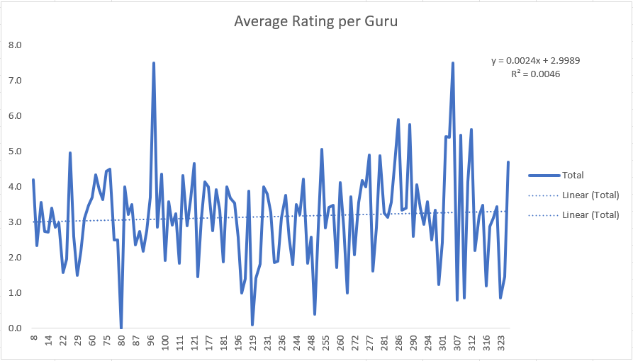

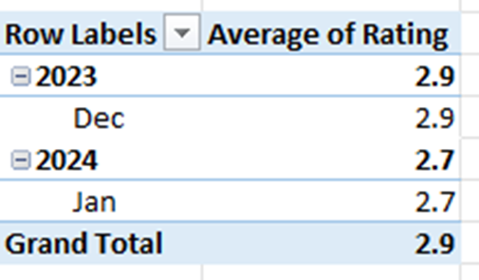

1. How should the call centre balance the workload among agents to ensure optimal performance and avoid burnout?

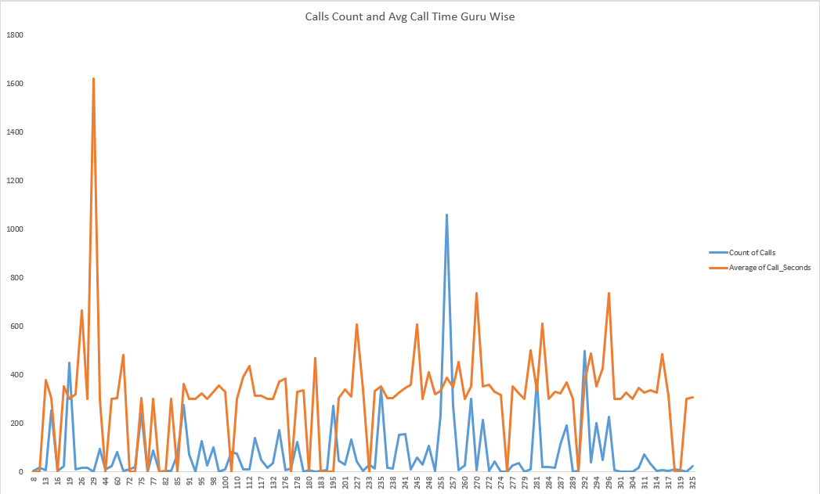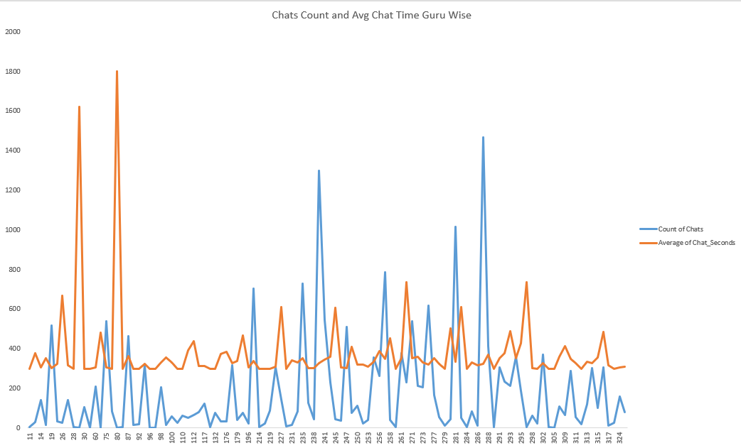

As we can see from above charts, which compare Average Call/Chat time and Count of Calls/Chats for each guru, we observe that: -

* The line graph of Count of Calls in mostly under the line graph of Average Call Seconds with some spikes in Call Seconds line graph, possibly causing burn out for those gurus.
* In Chats, none of the gurus have 0 chat time and initially chat time is more, chats are less but as we move towards later area of graph, count of chats becoming more and more and chat time is pretty much same, causing possible burnouts.
* In the Calls chart, G_id 29 has longest Call of 1620 sec but this agent has only done 1 call over the period. On the contrary, G_id 256 has made 1060 calls but average call time is 387 sec. So, division of workload is not up to the mark causing low ratings.
* Similarly in Chats graph, we can see that G_ids 29 and 80 has longer chat times but their count of chats is low. On the contrary, G_ids 239, 281 and 287 have more chat counts than any other agent but their chat times are less.
* The above two figures of Chats and Calls graph, shows that agents having more chat/call counts with less chat/call time might be able to resolve issues as fast than any other agents.

There are many ways: -

* Using Predictive analytics for forecasting high-volume periods, so that Agent allocation management can be improved
* Implementing Rotational Shifts. Avoid consistently assigning the same agents to peak hours.
* Using AI Chatbots to handle FAQs and reduce the number of calls reaching agents.
* Hiring part-time agents which can reduce load on High-rated agents. But training them is crucial to sustain in market.
* Schedule regular breaks to prevent fatigue and burnout during long shifts.

1. What new technologies or tools could be implemented to enhance call centre operations and customer service?

* **AI Chatbots**: Streamline initial interactions by identifying customer issues, saving agents time.
* **Predictive Analysis**: Forecast demand to optimize resource allocation, reduce agent pressure, and improve ratings.
* **Speech Analytics**: Monitor communication quality, identify areas for improvement, and refine training programs.
* **CRM System**: Enhance personalization and meet the needs of repeat callers effectively.

1. What metrics should be included in the final dashboard to provide a comprehensive view of call centre performance and guide investment decisions?



* Total Calls Handled and Total Chats Handled – keeps the track of overall workload on agents.
* Average Satisfaction Score – Evaluates overall customer happiness, showing how well the Customer trusts the agents.
* Total Revenue Generated – Profit made by the Company, depicting whether the business is profitable or not.
* Revenue per Call and Revenue per Chat – Profit made by Company on each call and each chat, showcasing which Consultation type is making more money.
* Call Completion Rate and Chat Completion rate – How much Calls and Chats are completed as compare to total number of Calls and Chats respectively, depicting the differences between Calls and Chats and helps in comparing the both Consultation types.

1. How would you allocate a 1 crore rupee investment to optimize operational efficiency, enhance customer satisfaction, and boost profitability, and what analysis-based recommendations would you offer to support this?

* **Training (₹30 Lakhs, 30%)**:  
  Focused training for low-rated agents, workshops to enhance communication and technical skills, and mentorship programs to improve average agent ratings.

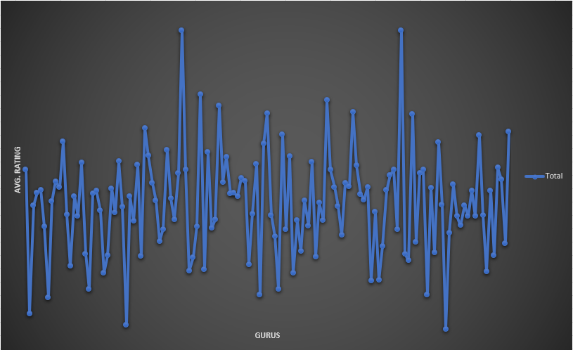

* **Technology Upgrades (₹50 Lakhs, 50%)**:  
  Address peak call volumes and low satisfaction scores with AI-powered chatbots, predictive analytics for demand forecasting, and speech analytics for call quality monitoring and improvement.



* **Hiring (₹20 Lakhs, 20%)**:  
  Reduce agent workload during peak hours by hiring part-time agents and recruiting full-time astrologically qualified agents to build customer trust and satisfaction.

